**Department of Computer Science & Engineering**

**Lab Manual**

**Subject Name: Machine Learning I Lab**

**Subject Code:**

**17BTIS612/17MIIA612**

**Student Name**: Garvin Chanderia

**Year**: TY **Branch**: Intelligent Systems

**Roll Number**: 2203132

**Enrollment Number**: MITU20BTCS0100

ASSIGNMENT – Downloading

**Problem Statement-**

Installation and Configuration of machine learning environment with Anaconda on windows or Ubuntu (Jupyter notebook)

# Objective

To install anaconda and configure it with Python

# Theory

Installation Of Anaconda in Windows

1. Visit the Anaconda downloads page

Go to the following link: [Anaconda.com/downloads](https://www.anaconda.com/download/)



1. Select Windows

Select Windows where the three operating systems are listed.

Anaconda downloads page. Windows download option is selected

1. Download

Download the most recent Python 3 release. At the time of writing, the most recent release was the Python 3.6 Version. Python 2.7 is legacy Python. For problem solvers, select the Python 3.6 version. If you are unsure if your computer is running a 64-bit or 32-bit version of Windows, select 64-bit as 64- bit Windows is most common.



1. Open and run the installer

Once the download completes, open and run the ***.exe*** installer

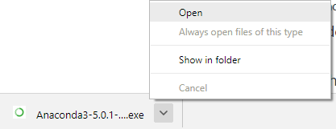

At the beginning of the install, you need to click **Next** to confirm the installation.



At the Advanced Installation Options screen, I recommend that you **do not check** "Add Anaconda to my PATH environment variable"



Installation Of Anaconda in Ubuntu

This section details the installation of the Anaconda distribution of Python on Linux, specifically Ubuntu 18.04, but the instructions should work for other Debian-based Linux distributions as well.

Ubuntu 18.04 comes pre-installed with Python (Version 3.6) and legacy Python (Version 2.7). You can confirm the legacy version of Python is installed by opening up a terminal.

1. Visit the Anaconda downloads page

Go to the following link: [Anaconda.com/downloads](https://www.anaconda.com/download/)



1. Select Linux

On the downloads page, select the Linux operating system.

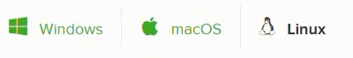

1. Copy the bash (.sh file) installer link

In the **Python 3.6 Version\*** box, right-click on the [64-Bit(x86) Installer] link. Select [copy link address].



1. Use wget to download the bash installer

Now that the bash installer (.sh file) link is stored on the clipboard, use wget to download the installer script. In a terminal, cd into the home directory and make a new directory called tmp. cd into tmp and use wget to download the installer. Although the installer is a bash script, it is still quite large and the download will not be immediate (Note the link below includes <release>. the specific release depends on when you download the installer)

$ cd ~

$ mkdir tmp

$ cd tmp

$ [https://repo.continuum.io/archive/Anaconda3<release>.sh](https://repo.continuum.io/archive/Anaconda3%3crelease%3e.sh)

1. Run the bash script to install **Anaconda3**

With the bash installer script downloaded, run the ***.sh*** script to install **Anaconda3**. Ensure you are in the directory where the installer script downloaded:

$ ls

Anaconda3-5.2.0-Linux-x86_64.sh Run the installer script with bash.

$ bash Anaconda3-5.2.0-Linux-x86_64.sh

Accept the Licence Agreement and allow Anaconda to be added to your PATH. By adding Anaconda to your PATH, the Anaconda distribution of Python will be called when you type $ python in a terminal.

1. source the .bash-rc file to add Anaconda to your PATH

Now that **Anaconda3** is installed and **Anaconda3** is added to our PATH, source the .bashrc file to load the new PATH environment variable into the current terminal session. Note the .bashrc file is in the home directory. You can see it with $ ls -a.

$ cd ~

$ source .bashrc

Installation Of NumPy Command – pip3 install numpy To check the version

Import numpy as np

Installation of Scipy-stack Command – pip3 install scipy-stack

NUMPY/SCIPY:-

NumPy is a Python library, which stands for ‘Numerical Python’. It is the core library for scientific computing, which contains a powerful n-dimensional array object, provide tools for integrating C, C++ etc.

* NumPy array can also be used as an efficient multi-dimensional container for generic .data.
* The ndarray (NumPy Array) is a multidimensional array used to store values of same datatype. These arrays are indexed just like Sequences, starts with zero.
* The ndarrays are better than regular arrays in terms of faster computation and ease of manipulation.
* In different algorithms of Machine Learning like K-means Clustering, Random Forest etc. we have to store the values in an array. So, instead of using regular array, ndarray helps us to manipulate and execute easily.

Installation of scikit

Command pip3 install -u scikit-learn

SCIKIT:-

The functionality that scikit-learn provides include:

* **Regression**, including Linear and Logistic Regression
* **Classification**, including K-Nearest Neighbors
* **Clustering**, including K-Means and K-Means++

# Model selection

* **Preprocessing**, including Min-Max Normalization.

Installation of Pandas

Command- pip3 install pandas

PANDAS:-

* Merging and Joining Data Sets.
* Reshaping & pivoting Data Sets.
* Inserting & deleting columns in Data Structure.
* Aligning data & dealing with missing data.
* Iterating over a Data set.
* Analyzing Time Series.
* Filtering Data around a condition.
* Arranging Data in an ascending & descending.
* Reading from flies with CSV, TXT, XLSX, other formats.
* Manipulating Data using integrated indexing for DataFrame objects.
* Generating Data range, date shifting, lagging, converting frequency, and other other Time Series functionality.
* Subsettting fancy indexing, & label based slicing Data Sets that are large in size.
* Performing split apply combine on Data Sets using the group by engine. With Python Pandas, it is easier to clean & wrangle with your Data. features of Pandas make it a great choice for Data Science and Analysis.

Installation of Matplotlib Command- pip3 install matplotlib

MATPLOTLIB:-

* Matplotlib is a visualization library in Python for 2D plots of arrays. It consists of several plots like line, bar, scatter, histogram etc.
* Matplotlib is a multi-platform data visualization library built on NumPy arrays and designed to work with the broader SciPy [stack.It](http://stack.it/) can also be used with graphics toolkits like PyQt and wxPython.
* One of the advantage of visualization is that it allows us visual access to huge amounts of data in easily digestible visuals.

# Conclusion

Thus we have successfully installed Anaconda on windows and Ubuntu; We also have described the libraries and the installation of the libraries.

Assignment 2 – EDA

Aim: Download any dataset from UCI or Data.org or from any data repositories and perform the basic data pre-processing steps using Python/R

Objectives:

1. Learn to pre-process dataset
2. Learn to use pandas and sklearn

# Theory Basic steps

**Step 1 :** Import the libraries

**Step 2 :** Import the data-set

**Step 3 :** Check out the missing values

**Step 4 :** See the Categorical Values

**Step 5 :** Splitting the data-set into Training and Test Set

# Data cleaning:

The main aim of Data Cleaning is to identify and remove errors & duplicate data, in order to create a reliable dataset. This improves the quality of the training data for analytics and enables accurate decision-making.

Needless to say, data cleansing is a time-consuming process and most data scientists spend an enormous amount of time in enhancing the quality of the data. However, there are various methods to identify and classify data for data cleansing.

There are mainly two distinct techniques, namely Qualitative and Quantitative techniques to classify data errors. Qualitative techniques involve rules, constraints, and patterns to identify errors.

On the other hand, Quantitative techniques employ statistical techniques to identify errors in the trained data.

Normalisation:

# Normalization is a scaling technique in which values are shifted and rescaled so that they end up ranging between 0 and 1. It is also known as Min-Max scaling.

Here’s the formula for normalization:



Here, Xmax and Xmin are the maximum and the minimum values of the feature respectively.

* When the value of X is the minimum value in the column, the numerator

will be 0, and hence X’ is 0

* On the other hand, when the value of X is the maximum value in the column, the numerator is equal to the denominator and thus the value of X’ is 1
* If the value of X is between the minimum and the maximum value, then

the value of X’ is between 0 and 1

Standardisation:

# Standardization is another scaling technique where the values are centered around the mean with a unit standard deviation. This means that the mean of the attribute becomes zero and the resultant distribution has a unit standard deviation.

Here’s the formula for standardization:



Feature scaling: MuFeature scaling: Sigmais the mean of the feature values and is the standard deviation of the feature values. Note that in this case, the values are not restricted to a particular range.

X_train,X_test,y_train,y_test= train_test_split(X,y,test_size=0.2,random_state= 0)

Split arrays or matrices into random train and test subsets Quick utility that wraps input validation

and next(ShuffleSplit().split(X, y)) and application to input data into a single call for splitting (and optionally subsampling) data in a oneliner.

Imputer(missing_values='NaN', strategy='mean', axis=0) Imputation transformer for completing missing values.

pandas.read_csv()

Read a comma-separated values (csv) file into DataFrame.

Also supports optionally iterating or breaking of the file into chunks.

# Program:

Import the libraries import numpy as np

import matplotlib.pyplot as plt import pandas as pd

Importing the dataset dataset=pd.read_csv('data.csv') X=dataset.iloc[:,:-1].values y=dataset.iloc[:,3].values

Checking out Missing data

from sklearn.preprocessing import Imputer imputer=Imputer(missing_values='NaN', strategy='mean', axis=0) imputer=imputer.fit(X[:,1:3])

X[:,1:3]=imputer.transform(X[:,1:3])

Checking the categorical values

from sklearn.preprocessing import LabelEncoder labelencoder_X=LabelEncoder() X[:,0]=labelencoder_X.fit_transform(X[:,0]) labelencoder_y=LabelEncoder() y=labelencoder_y.fit_transform(y)

Splitting the dataset into Training Set and Testing Set from sklearn.cross_validation import train_test_split

X_train,X_test,y_train,y_test= train_test_split(X,y,test_size=0.2,random_state= 0)

# Output:

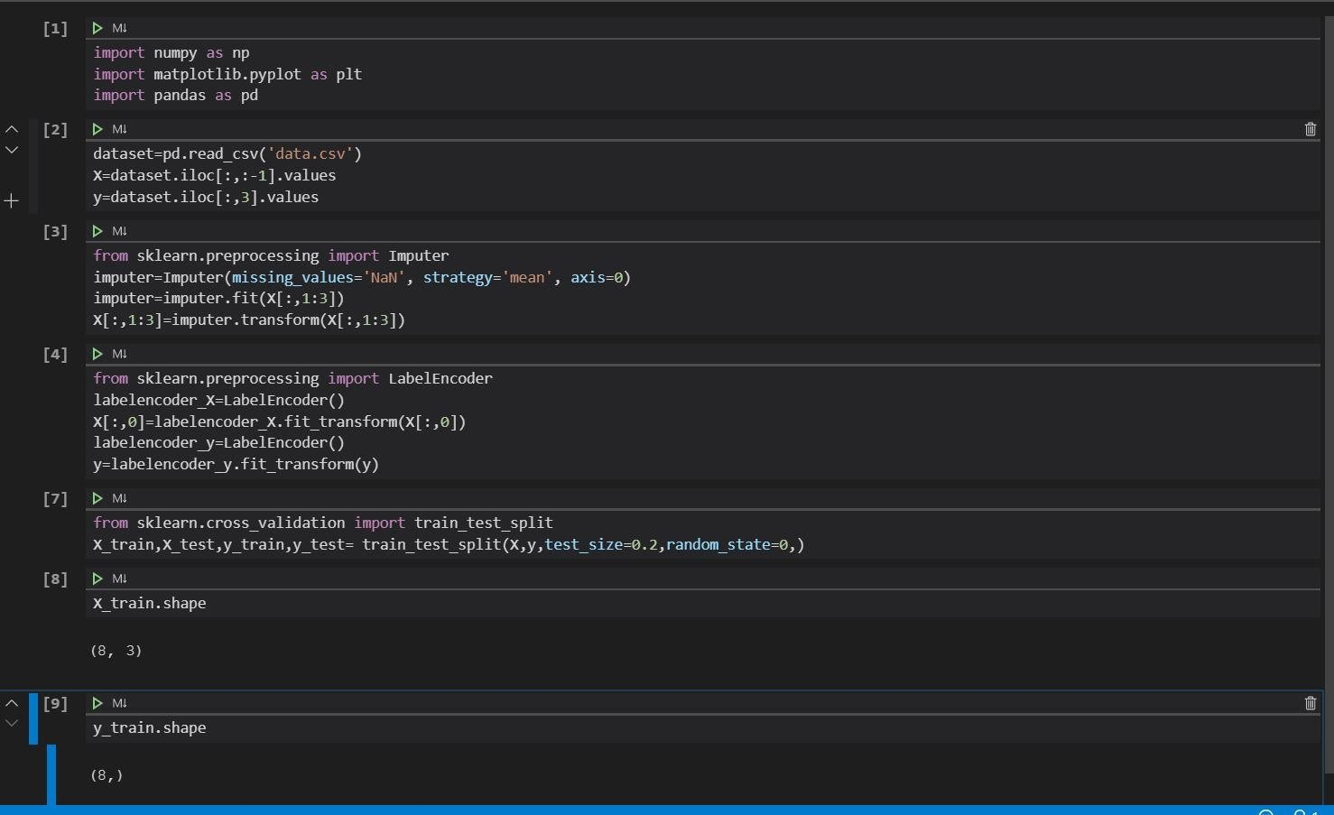

Conclusion:

Thus we have successfully implemented pre-processing operations on a dataset

Assignment 3 – Multi Layer Perceptron

**Aim:** Download the any dataset from UCI or Data.org or from any other data repositories and Implement Single and multilayer perceptron on a dataset.

# Objectives:

1. To learn about classification and regression
2. To learn MLP and backpropagation
3. To demonstrate and analyse the results

Theory:

Regression:

A regression problem is when the output variable is a real or continuous value, such as “salary” or “weight”. Many different models can be used, the simplest is the linear regression. It tries to fit data with the best hyper-plane which goes through the points.

Classification:

A classification problem is when the output variable is a category, such as “red” or “blue” or “disease” and “no disease”. A classification model attempts to draw some conclusion from observed values. Given one or more inputs a classification model will try to predict the value of one or more outcomes. For example, when filtering emails “spam” or “not spam”, when looking at transaction data, “fraudulent”, or “authorized”.

Multilayer Perceptron:

In the Multilayer perceptron, there can more than one linear layer (combinations of **neurons**). If we take the simple example the three-layer network, first layer will be the *input layer* and last will be *output layer* and middle layer will be called *hidden layer.* We feed our input data into the input layer and take the

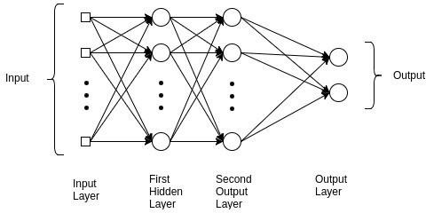output from the output layer. We can increase the number of the hidden layer as much as we want, to make the model more complex according to our task.

BackPropagation Algorithm:

**The algorithm is used to effectively train a neural network through a method called chain rule.** In simple terms, after each forward pass through a network, backpropagation performs a backward pass while adjusting the model’s parameters (weights and biases).

In other words, **backpropagation aims to minimize the cost function by adjusting network’s weights and biases.** The level of adjustment is determined by the gradients of the cost function with respect to those parameters.

Activation function

Activation functions also known non- linearity, describe the input-output relations in a non-linear way. This gives the model power to be more flexible in describing arbitrary relations. Here are some popular activation functions Sigmoid, Relu, and TanH. I will describe these in my next blog.

**Precision** - Precision is the ratio of correctly predicted positive observations to the total predicted positive observations. The question that this metric answer is of all passengers that labeled as survived, how many actually survived? High precision relates to the low false positive rate. We have got 0.788 precision which is pretty good.

Precision = TP/TP+FP

**Recall** (Sensitivity) - Recall is the ratio of correctly predicted positive observations to the all observations in actual class - yes. The question recall answers is: Of all the passengers that truly survived, how many did we label? We have got recall of 0.631 which is good for this model as it’s above 0.5.

Recall = TP/TP+FN

**F1 score** - F1 Score is the weighted average of Precision and Recall. Therefore, this score takes both false positives and false negatives into account. Intuitively it is not as easy to understand as accuracy, but F1 is usually more useful than accuracy, especially if you have an uneven class distribution. Accuracy works best if false positives and false negatives have similar cost. If the cost of false positives and false negatives are very different, it’s better to look at both Precision and Recall. In our case, F1 score is 0.701.

F1 Score = 2*(Recall * Precision) / (Recall + Precision) Confusion matrix

A confusion matrix is a summary of prediction results on a classification

problem. The number of correct and incorrect predictions are summarized with count values and broken down by each class. This is the key to the confusion matrix. The confusion matrix shows the ways in which your classification model is confused when it makes predictions. It gives us insight not only into the errors being made by a classifier but more importantly the types of errors that are being made.

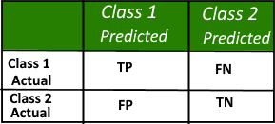

Code:

import pandas as pd

df=pd.read_csv('kc_house_data.csv') df_=df.dropna(axis=1,how='any')

from sklearn.model_selection import train_test_split from sklearn.preprocessing import StandardScaler obj=StandardScaler()

x=df_.iloc[:,3:15] x_=obj.fit_transform(x) y=df['price'].values

X_train, X_test, y_train, y_test = train_test_split(x_, y, test_size=0.2,rando m_state=42)

from sklearn.neural_network import MLPRegressor mlp=MLPRegressor(hidden_layer_sizes=(175,),activation='relu',solver='lbfgs',le arning_rate='adaptive',verbose=True,max_iter=100)

mlp.fit(X_train,y_train) print(mlp.score(X_test,y_test)*100) Dataset:

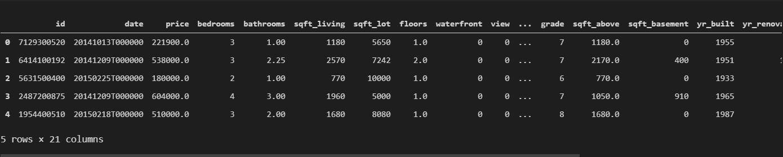

Training

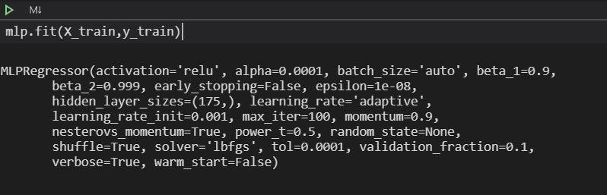

Results

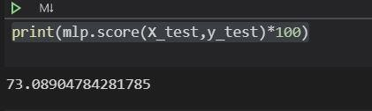

Conclusion

Thus we have successfully completed the implementation of Multilayer perceptron.

Assignment 4 – Naïve Bayes

Aim: Develop a Bayesian classifier IRIS dataset dataset

# Objectives

1. To learn bayes theorem
2. To implement Bayesian classifier

Theory

Bayes Theorem

Bayes’ Theorem is a way of finding a [probability](https://www.mathsisfun.com/data/probability.html) when we know certain other probabilities.

The formula is:

P(A|B) = *P(A) P(B|A)***P(B)**

|  |  |
| --- | --- |
| Which tells us: | how often A happens *given that B happens*, written **P(A|B)**, |
| When we know: | how often B happens *given that A happens*, written **P(B|A)** |
|  | and how likely A is on its own, written **P(A)** |
|  | and how likely B is on its own, written **P(B)** |

Bayes Classifier with example

In [machine learning](https://en.wikipedia.org/wiki/Machine_learning), **naïve Bayes classifiers** are a family of simple "[probabilistic](https://en.wikipedia.org/wiki/Probabilistic_classification) [classifiers](https://en.wikipedia.org/wiki/Probabilistic_classification)" based on applying [Bayes' theorem](https://en.wikipedia.org/wiki/Bayes%27_theorem) with strong (naïve) [independence](https://en.wikipedia.org/wiki/Statistical_independence) assumptions between the features. They are among the simplest [Bayesian network](https://en.wikipedia.org/wiki/Bayesian_network) models.[[1]](https://en.wikipedia.org/wiki/Naive_Bayes_classifier#cite_note-1) But they could be coupled with [Kernel](https://en.wikipedia.org/wiki/Kernel_density_estimation) [density estimation](https://en.wikipedia.org/wiki/Kernel_density_estimation) and achieve higher accuracy levels.

Naive Bayes is a simple technique for constructing classifiers: models that assign class labels to problem instances, represented as vectors of [feature](https://en.wikipedia.org/wiki/Feature_vector) values, where the class labels are drawn from some finite set. There is not a single [algorithm](https://en.wikipedia.org/wiki/Algorithm) for training such classifiers, but a family of algorithms based on a common principle: all naive Bayes classifiers assume that the value of a

particular feature is [independent](https://en.wikipedia.org/wiki/Independence_(probability_theory)) of the value of any other feature, given the class variable. For example, a fruit may be considered to be an apple if it is red, round, and about 10 cm in diameter. A naive Bayes classifier considers each of these features to contribute independently to the probability that this fruit is an apple, regardless of any possible [correlations](https://en.wikipedia.org/wiki/Correlation_and_dependence) between the color, roundness, and diameter features.

Code

import pandas as pd

from sklearn.naive_bayes import GaussianNB df_=pd.read_csv('IRIS.csv') df_=df_.dropna(axis=1,how='any')

from sklearn.preprocessing import StandardScaler from sklearn.model_selection import train_test_split from sklearn.neural_network import MLPClassifier from sklearn.preprocessing import LabelEncoder

le = LabelEncoder()

le.fit(["Iris-setosa", "Iris-versicolor", "Iris-viginica"]) le.transform(["Iris-setosa", "Iris-versicolor", "Iris-viginica"])

x=df_.iloc[:,0:3]

obj=StandardScaler() x_=obj.fit_transform(x) y=df_['species']

X_train, X_test, y_train, y_test = train_test_split(x_, y, test_size=0.4,rando m_state=42)

X_validate, X_test1, y_validate, y_test1=train_test_split(X_test,y_test,test_s ize=0.5,random_state=42)

bayes=GaussianNB(priors=None) bayes.fit(X_train,y_train) print(bayes.score(X_validate,y_validate)) print(bayes.score(X_test1,y_test1))

Iris dataset

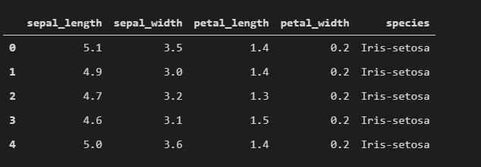

Training

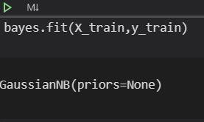

Results

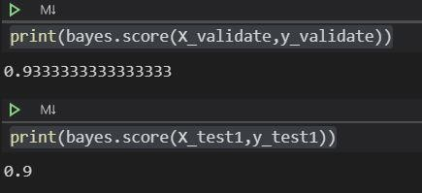

Conclusion

Thus we have successfully completed the implementation of Naïve Bayes Gaussian Classifier.

Assignment 5 – Linear Regression

Aim: Prepare the Correlated dataset of your own example or Download the any one of the UCI ML data Set in which find the correlated data and Find the best fit line for the data

Objectives:

1. To learn linear regression
2. To learn and understand correlated datasets

Theory

Linear Regression:

Linear regression is a statistical approach for modelling relationship between a dependent variable with a given set of independent variables.

Simple linear regression is an approach for predicting a **response** using a **single feature**.

It is assumed that the two variables are linearly related. Hence, we try to find a linear function that predicts the response value(y) as accurately as possible as a function of the feature or independent variable(x).

Multiple linear regression attempts to model the relationship between **two or more features** and a response by fitting a linear equation to observed data.

Clearly, it is nothing but an extension of Simple linear regression.

Logistic regression:

Logistic regression is another technique borrowed by machine learning from the field of statistics.

It is the go-to method for binary classification problems (problems with two class values). In this post you will discover the logistic regression algorithm for machine learning.

Logistic regression is named for the function used at the core of the method, the logistic function.

The [logistic function](https://en.wikipedia.org/wiki/Logistic_function), also called the sigmoid function was developed by statisticians to describe properties of population growth in ecology, rising quickly and maxing out at the carrying capacity of the environment. It’s an S- shaped curve that can take any real-valued number and map it into a value between 0 and 1, but never exactly at those limits.

1 / (1 + e^-value)

Where e is the [base of the natural logarithms](https://en.wikipedia.org/wiki/E_(mathematical_constant)) (Euler’s number or the EXP() function in your spreadsheet) and value is the actual numerical value that you want to transform. Below is a plot of the numbers between -5 and 5 transformed into the range 0 and 1 using the logistic function.

Correlated datasets:

They follow the property of Correlation

Correlation is a statistical measure that indicates the extent to which two or more [variables](https://whatis.techtarget.com/definition/variable) fluctuate together. A [positive correlation](https://whatis.techtarget.com/definition/positive-correlation) indicates the extent to which those variables increase or decrease in parallel; a [negative](https://whatis.techtarget.com/definition/negative-correlation) [correlation](https://whatis.techtarget.com/definition/negative-correlation) indicates the extent to which one variable increases as the other decreases.

A [correlation coefficient](https://whatis.techtarget.com/definition/correlation-coefficient) is a statistical measure of the degree to which changes to the value of one variable predict change to the value of another. When the fluctuation of one variable reliably predicts a similar fluctuation in another variable, there’s often a tendency to think that means that the change in one causes the change in the other. However, correlation does not imply [causation](https://whatis.techtarget.com/definition/causation). There may be, for example, an unknown factor that influences both variables similarly.

Code:

import pandas as pd import numpy as np

import matplotlib.pyplot as plt

from sklearn.model_selection import train_test_split

from sklearn.linear_model import LinearRegression from sklearn import metrics

from sklearn.preprocessing import LabelEncoder from sklearn.preprocessing import StandardScaler

df_=pd.read_csv('IRIS.csv') df_=df_.dropna(axis=1,how='any') df_.head()

le=LabelEncoder()

#le.fit_transform(["Iris-setosa", "Iris-versicolor", "Iris-virginica"]) df_['species']= le.fit_transform(df_['species'])

x=df_.iloc[:,0:1] obj=StandardScaler() x_=obj.fit_transform(x) y=df_['species']

X_train, X_test, y_train, y_test = train_test_split(x, y, test_size=0.2, random_state=0)

reg = LinearRegression() reg.fit(X_train, y_train) y_pred = reg.predict(X_test)

plt.scatter(X_test, y_test, color='gray') plt.plot(X_test, y_pred, color='red', linewidth=2) plt.show()

Dataset:

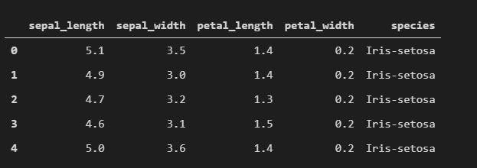

Training

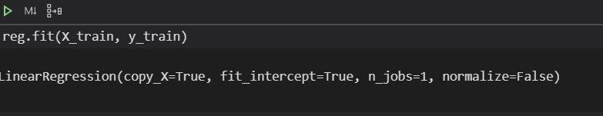

Results

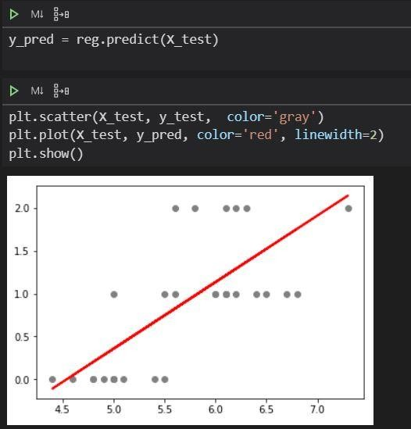

Assignment 6 - PCA

Aim: Using inbuilt dataset of Breast cancer from scikit learn Implement PCA algorithm.

# Objectives:

1. To learn about dimensionality reduction techniques
2. To implement principle component analysis

Theory:

Curse of Dimensionality

The **curse of dimensionality** refers to various phenomena that arise when analyzing and organizing data in [high-dimensional spaces](https://en.wikipedia.org/wiki/High-dimensional_space) (often with hundreds or thousands of dimensions) that do not occur in low-dimensional settings such as the [three-dimensional](https://en.wikipedia.org/wiki/Three-dimensional_space) [physical space](https://en.wikipedia.org/wiki/Physical_space) of everyday experience. The expression was coined by [Richard E. Bellman](https://en.wikipedia.org/wiki/Richard_E._Bellman) when considering problems in [dynamic](https://en.wikipedia.org/wiki/Dynamic_programming) [programming](https://en.wikipedia.org/wiki/Dynamic_programming).[[1]](https://en.wikipedia.org/wiki/Curse_of_dimensionality#cite_note-1)[[2]](https://en.wikipedia.org/wiki/Curse_of_dimensionality#cite_note-2)

Cursed phenomena occur in domains such as [numerical](https://en.wikipedia.org/wiki/Numerical_analysis) [analysis](https://en.wikipedia.org/wiki/Numerical_analysis), [sampling](https://en.wikipedia.org/wiki/Sampling_(statistics)), [combinatorics](https://en.wikipedia.org/wiki/Combinatorics), [machine learning](https://en.wikipedia.org/wiki/Machine_learning), [data](https://en.wikipedia.org/wiki/Data_mining) [mining](https://en.wikipedia.org/wiki/Data_mining) and [databases](https://en.wikipedia.org/wiki/Database). The common theme of these problems is that when the dimensionality increases, the [volume](https://en.wikipedia.org/wiki/Volume) of the space increases so fast that the available data become sparse. This sparsity is problematic for any method that requires [statistical significance](https://en.wikipedia.org/wiki/Statistical_significance). In order to obtain a statistically sound and reliable result, the amount of data needed to support the result often grows exponentially with the dimensionality. Also, organizing and searching data often relies on detecting areas where objects form groups with similar properties; in high dimensional data, however, all objects appear to be sparse and dissimilar in many ways, which prevents common data organization strategies from being efficient.

PCA

Given a collection of points in [two, three, or higher dimensional space](https://en.wikipedia.org/wiki/Real_coordinate_space), a "best fitting" line can be defined as one that minimizes the average squared distance from a point to the line. The next best-fitting line can be similarly chosen from directions perpendicular to the first. Repeating this process yields

an [orthogonal](https://en.wikipedia.org/wiki/Orthogonal) [basis](https://en.wikipedia.org/wiki/Basis_(linear_algebra)) in which different individual dimensions of the data are uncorrelated. These basis vectors are called **principal components**, and several related procedures **principal component analysis** (**PCA**).

PCA is mostly used as a tool in [exploratory data analysis](https://en.wikipedia.org/wiki/Exploratory_data_analysis) and for making [predictive models](https://en.wikipedia.org/wiki/Predictive_modeling). It is often used to visualize genetic distance and relatedness between populations. PCA is either done in the following 2 steps:

* 1. calculating the data [covariance](https://en.wikipedia.org/wiki/Covariance) (or [correlation](https://en.wikipedia.org/wiki/Correlation)) matrix of the original data
  2. performing [eigenvalue decomposition](https://en.wikipedia.org/wiki/Eigendecomposition_of_a_matrix) on the covariance matrix

LDA

**Linear discriminant analysis** (**LDA**), **normal discriminant analysis** (**NDA**), or **discriminant function analysis** is a generalization of **Fisher's linear discriminant**, a method used in [statistics](https://en.wikipedia.org/wiki/Statistics), [pattern recognition](https://en.wikipedia.org/wiki/Pattern_recognition), and [machine](https://en.wikipedia.org/wiki/Machine_learning) [learning](https://en.wikipedia.org/wiki/Machine_learning) to find a [linear combination](https://en.wikipedia.org/wiki/Linear_combination) of [features](https://en.wikipedia.org/wiki/Features_(pattern_recognition)) that characterizes or separates two or more classes of objects or events. The resulting combination may be used as a [linear classifier](https://en.wikipedia.org/wiki/Linear_classifier), or, more commonly, for [dimensionality reduction](https://en.wikipedia.org/wiki/Dimensionality_reduction) before later [classification](https://en.wikipedia.org/wiki/Statistical_classification).

LDA is closely related to [analysis of variance](https://en.wikipedia.org/wiki/Analysis_of_variance) (ANOVA) and [regression analysis](https://en.wikipedia.org/wiki/Regression_analysis), which also attempt to express one [dependent variable](https://en.wikipedia.org/wiki/Dependent_variable) as a linear combination of other features or measurements.

Difference between PCA AND LDA

LDA => This method identifies components (i.e., linear combination of the observed variables) that **maximize class separation (i.e. between-class variance**) when such prior information is available (i.e., supervised). E.g., you have a training set containing a variable specifying the class of each observation.

PCA => Aims to find components that account for **maximum variance in the data** (including error and within-variable variance). Unlike LDA, it does not take into account class membership (i.e., unsupervised), and is used when such information is not available. Importantly, both LDA and PCA do not require any prior notion of how the variables are related among themselves, and the

resulting components can not be interpreted in terms of an underlying construct.

Code

import pandas as pd

from sklearn.preprocessing import StandardScaler from sklearn.model_selection import train_test_split from sklearn.datasets import load_breast_cancer cancer=load_breast_cancer()

df = pd.DataFrame(cancer['data'], columns=cancer['feature_names']) df.head()

x=df.iloc[:,0:8]

y=df['mean fractal dimension']

from sklearn.decomposition import PCA pca=PCA(n_components=2) pc=pca.fit_transform(x) pdf=pd.DataFrame(data=pc,columns=['pc1','pc2']) pdf.head()

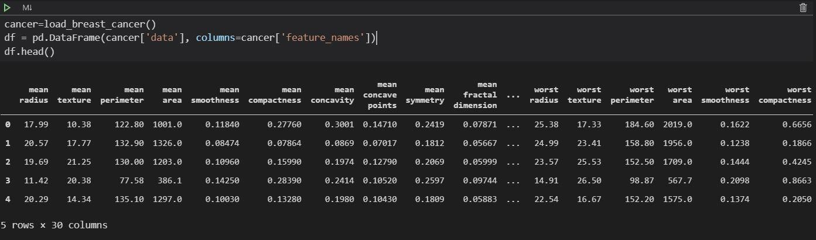Dataset

Results

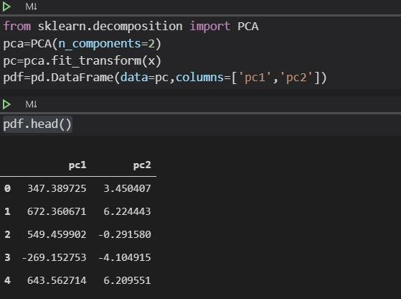

Conclusion

Thus we have successfully completed the implementation of the Principle component Analysis Algorithm.

Assignment 7- Decision Tree

Aim: Implement decision tree classification/regression technique for given dataset

Developed model should be able to answer the given queries.

# Objectives

1. To learn about decision trees
2. To implement decision trees and compare results

Theory:

Decision Tree:

Decision tree is the most powerful and popular tool for classification and prediction. A Decision tree is a flowchart like tree structure, where each internal node denotes a test on an attribute, each branch represents an outcome of the test, and each leaf node (terminal node) holds a class label.

A tree can be *“learned”* by splitting the source set into subsets based on an attribute value test. This process is repeated on each derived subset in a recursive manner called *recursive partitioning*. The recursion is completed when the subset at a node all has the same value of the target variable, or when splitting no longer adds value to the predictions. The construction of decision tree classifier does not require any domain knowledge or parameter setting, and therefore is appropriate for exploratory knowledge discovery. Decision trees can handle high dimensional data. In general decision tree classifier has good accuracy. Decision tree induction is a typical inductive approach to learn knowledge on classification.

Different types:

Decision trees used in [data mining](https://en.wikipedia.org/wiki/Data_mining) are of two main types:

* [**Classification tree**](https://en.wikipedia.org/wiki/Classification_tree) analysis is when the predicted outcome is the class (discrete) to which the data belongs.
* **Regression tree** analysis is when the predicted outcome can be considered a real number (e.g. the price of a house, or a patient's length of stay in a hospital).

The term **Classification And Regression Tree (CART)** analysis is an [umbrella](https://en.wikipedia.org/wiki/Umbrella_term) [term](https://en.wikipedia.org/wiki/Umbrella_term) used to refer to both of the above procedures, first introduced by [Breiman](https://en.wikipedia.org/wiki/Leo_Breiman) et al. in 1984.[[4]](https://en.wikipedia.org/wiki/Decision_tree_learning#cite_note-bfos-4) Trees used for regression and trees used for classification have some similarities - but also some differences, such as the procedure used to determine where to split.[[4]](https://en.wikipedia.org/wiki/Decision_tree_learning#cite_note-bfos-4)

Some techniques, often called *ensemble* methods, construct more than one decision tree:

* [**Boosted trees**](https://en.wikipedia.org/wiki/Gradient_boosted_trees) Incrementally building an ensemble by training each new instance to emphasize the training instances previously mis-modeled. A typical example is [AdaBoost](https://en.wikipedia.org/wiki/AdaBoost). These can be used for regression-type and classification-type problems.[[5]](https://en.wikipedia.org/wiki/Decision_tree_learning#cite_note-5)[[6]](https://en.wikipedia.org/wiki/Decision_tree_learning#cite_note-6)
* [**Bootstrap aggregated**](https://en.wikipedia.org/wiki/Bootstrap_aggregating) (or bagged) decision trees, an early ensemble method, builds multiple decision trees by repeatedly resampling training data with replacement, and voting the trees for a consensus prediction.[[7]](https://en.wikipedia.org/wiki/Decision_tree_learning#cite_note-7)

o A [**random forest**](https://en.wikipedia.org/wiki/Random_forest) classifier is a specific type of [bootstrap aggregating](https://en.wikipedia.org/wiki/Bootstrap_aggregating)

* **Rotation forest** – in which every decision tree is trained by first applying [principal component analysis](https://en.wikipedia.org/wiki/Principal_component_analysis) (PCA) on a random subset of the input features.[[8]](https://en.wikipedia.org/wiki/Decision_tree_learning#cite_note-8)

A special case of a decision tree is a [decision list](https://en.wikipedia.org/wiki/Decision_list),[[9]](https://en.wikipedia.org/wiki/Decision_tree_learning#cite_note-9) which is a one-sided decision tree, so that every internal node has exactly 1 leaf node and exactly 1 internal node as a child (except for the bottommost node, whose only child is a single leaf node). While less expressive, decision lists are arguably easier to understand than general decision trees due to their added sparsity, permit non-greedy learning methods[[10]](https://en.wikipedia.org/wiki/Decision_tree_learning#cite_note-10) and monotonic constraints to be imposed.[[11]](https://en.wikipedia.org/wiki/Decision_tree_learning#cite_note-11)

Notable decision tree algorithms include:

* [ID3](https://en.wikipedia.org/wiki/ID3_algorithm) (Iterative Dichotomiser 3)
* [C4.5](https://en.wikipedia.org/wiki/C4.5_algorithm) (successor of ID3)
* [CART](https://en.wikipedia.org/wiki/Predictive_analytics#Classification_and_regression_trees_.28CART.29) (Classification And Regression Tree)[[4]](https://en.wikipedia.org/wiki/Decision_tree_learning#cite_note-bfos-4)
* [Chi-square automatic interaction detection](https://en.wikipedia.org/wiki/Chi-square_automatic_interaction_detection) (CHAID). Performs multi-level splits when computing classification trees.[[12]](https://en.wikipedia.org/wiki/Decision_tree_learning#cite_note-12)
* [MARS](https://en.wikipedia.org/wiki/Multivariate_adaptive_regression_splines): extends decision trees to handle numerical data better.
* Conditional Inference Trees. Statistics-based approach that uses non- parametric tests as splitting criteria, corrected for multiple testing to avoid overfitting. This approach results in unbiased predictor selection and does not require pruning.[[13]](https://en.wikipedia.org/wiki/Decision_tree_learning#cite_note-Hothorn2006-13)[[14]](https://en.wikipedia.org/wiki/Decision_tree_learning#cite_note-Strobl2009-14)

ID3 and CART were invented independently at around the same time (between 1970 and 1980)[*citation needed*], yet follow a similar approach for learning a decision tree from training tuples.

Difference between decision tree classification and regression Comparison Chart

|  |  |  |
| --- | --- | --- |
| **BASIS FOR COMPARISON** | **CLASSIFICATION** | **REGRESSION** |
| Basic | The discovery of model or functions where the mapping of objects is done into predefined classes. | A devised model in which the mapping of objects is done into values. |
| Involves prediction of | Discrete values | Continuous values |
| Algorithms | Decision tree, logistic regression, etc. | Regression tree (Random  forest), Linear regression, etc. |

|  |  |  |
| --- | --- | --- |
| **BASIS FOR COMPARISON** | **CLASSIFICATION** | **REGRESSION** |
| Nature of the predicted data | Unordered | Ordered |
| Method of  calculation | Measuring accuracy | Measurement of root  mean square error |

Visualising decision trees

|  |  |  |  |  |
| --- | --- | --- | --- | --- |
| from | sklearn.externals.six |  | import | StringIO |
| from | IPython.display |  | import | Image |
| from | sklearn.tree | import |  | export_graphviz |

import pydotplusdot_data = StringIO()

# export_graphviz(dtree, out_file=dot_data, filled=True, rounded=True,

**special_characters=True)**

graph = pydotplus.graph_from_dot_data(dot_data.getvalue()) Image(graph.create_png())

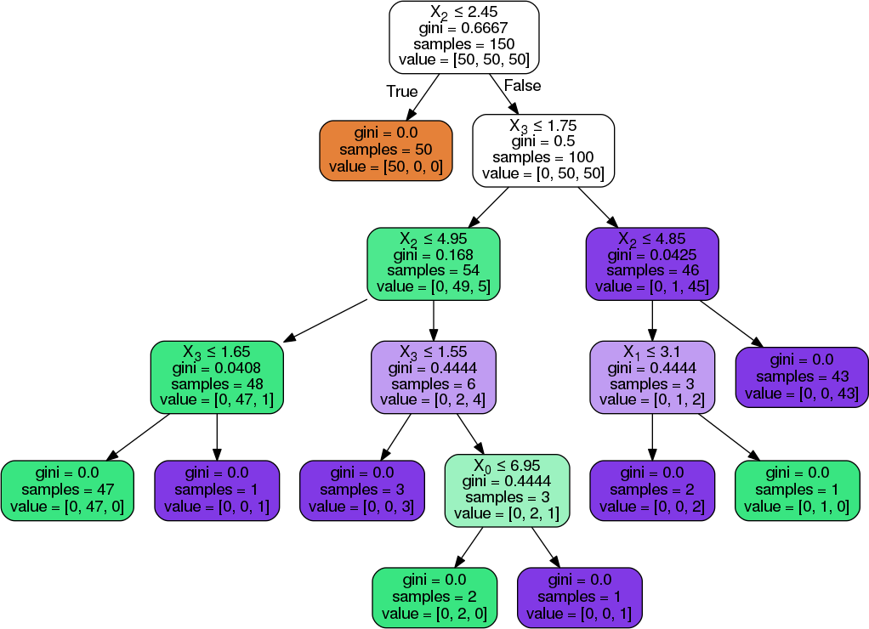

Code

import pandas as pd

from sklearn.tree import DecisionTreeClassifier

from sklearn.model_selection import train_test_split from sklearn.preprocessing import StandardScaler import matplotlib.pyplot as plt

from sklearn.preprocessing import LabelEncoder from sklearn.tree import export_graphviz import pydotplus

from sklearn.externals.six import StringIO from IPython.display import Image

from pydot import graph_from_dot_data df=pd.read_csv("train.csv") df.fillna(method="ffill",inplace=True) df1=pd.read_csv("test.csv") df1.fillna(method="ffill",inplace=True) df2=pd.read_csv("gender_submission.csv") df2.fillna(method="ffill",inplace=True) le=LabelEncoder() df["Name"]=le.fit_transform(df["Name"]) df["Sex"]=le.fit_transform(df["Sex"]) df["Ticket"]=le.fit_transform(df["Ticket"])

#df["Cabin"]=le.fit_transform(df["Cabin"]) df["Embarked"]=le.fit_transform(df["Embarked"]) df1["Sex"]=le.fit_transform(df1["Sex"]) df1["Ticket"]=le.fit_transform(df1["Ticket"]) #df["Cabin"]=le.fit_transform(df["Cabin"]) df1["Embarked"]=le.fit_transform(df1["Embarked"]) x=df.iloc[:,[0,2,4,5,6,7,8,9,11]]

y=df["Survived"] obj=StandardScaler() x=obj.fit_transform(x) df

x1=df1.iloc[:,[0,1,3,4,5,6,7,8,10]]

y1=df2["Survived"] x1=obj.fit_transform(x1) df1

x2=df2.iloc[:,0] y2=df2["Survived"] dt=DecisionTreeClassifier() dt.fit(x,y) print(dt.score(x1,y1)) print(dt.score(x,y))

Dataset

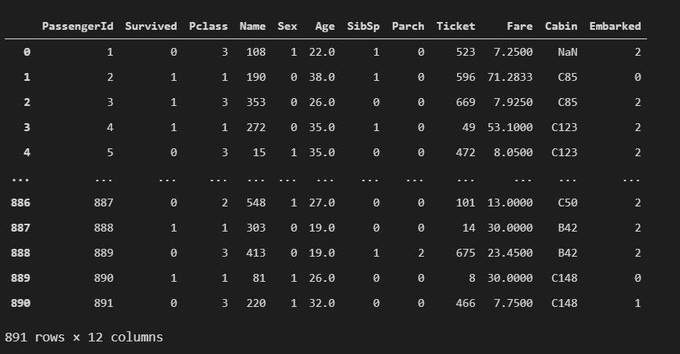

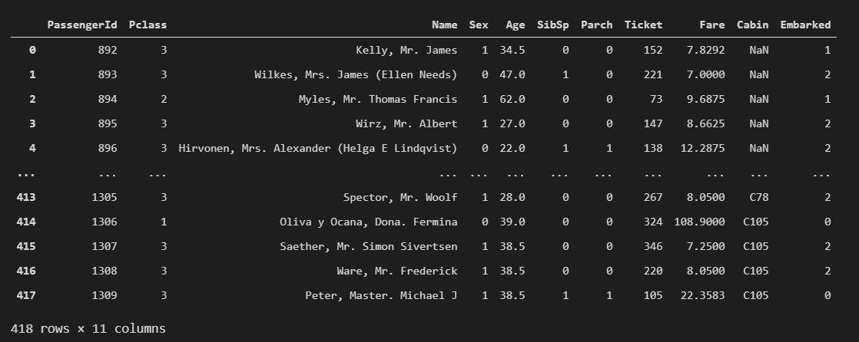

Training

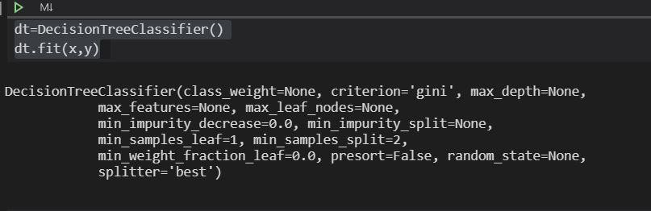

Results

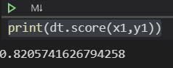

Conclusion

Thus we have successfully completed the implementation of decision tree classifier.

Assignment 8 - SVM

Aim: Implement SVM Classifier or Regression for given dataset

# Objectives:

1. To learn SVM and kernel functions
2. To implement SVM classifier Theory:

SVM:

**support-vector machines** (**SVMs**, also **support-vector networks**[[1]](https://en.wikipedia.org/wiki/Support-vector_machine#cite_note-CorinnaCortes-1)) are [supervised learning](https://en.wikipedia.org/wiki/Supervised_learning) models with associated learning [algorithms](https://en.wikipedia.org/wiki/Algorithm) that analyze data used for [classification](https://en.wikipedia.org/wiki/Statistical_classification) and [regression analysis](https://en.wikipedia.org/wiki/Regression_analysis). Given a set of training examples, each marked as belonging to one or the other of two categories, an SVM training algorithm builds a model that assigns new examples to one category or the other, making it a non-[probabilistic](https://en.wikipedia.org/wiki/Probabilistic_classification) [binary](https://en.wikipedia.org/wiki/Binary_classifier) [linear](https://en.wikipedia.org/wiki/Linear_classifier) [classifier](https://en.wikipedia.org/wiki/Linear_classifier) (although methods such as [Platt scaling](https://en.wikipedia.org/wiki/Platt_scaling) exist to use SVM in a probabilistic classification setting). An SVM model is a representation of the examples as points in space, mapped so that the examples of the separate categories are divided by a clear gap that is as wide as possible. New examples are then mapped into that same space and predicted to belong to a category based on the side of the gap on which they fall.

In addition to performing [linear classification](https://en.wikipedia.org/wiki/Linear_classifier), SVMs can efficiently perform a non-linear classification using what is called the [kernel trick](https://en.wikipedia.org/wiki/Kernel_method#Mathematics%3A_the_kernel_trick), implicitly mapping their inputs into high-dimensional feature spaces.

Kernel function

In [machine learning](https://en.wikipedia.org/wiki/Machine_learning), **kernel methods** are a class of algorithms for [pattern](https://en.wikipedia.org/wiki/Pattern_analysis) [analysis](https://en.wikipedia.org/wiki/Pattern_analysis), whose best known member is the [support vector machine](https://en.wikipedia.org/wiki/Support_vector_machine) (SVM). The general task of pattern analysis is to find and study general types of relations (for example [clusters](https://en.wikipedia.org/wiki/Cluster_analysis), [rankings](https://en.wikipedia.org/wiki/Ranking), [principal](https://en.wikipedia.org/wiki/Principal_components) [components](https://en.wikipedia.org/wiki/Principal_components), [correlations](https://en.wikipedia.org/wiki/Correlation), [classifications](https://en.wikipedia.org/wiki/Statistical_classification)) in datasets. For many algorithms that solve these tasks, the data in raw representation have to be explicitly transformed into [feature vector](https://en.wikipedia.org/wiki/Feature_vector) representations via a user-specified *feature map*: in contrast, kernel methods require only a user-specified *kernel*, i.e., a [similarity function](https://en.wikipedia.org/wiki/Similarity_function) over pairs of data points in raw representation.

Kernel methods owe their name to the use of [kernel functions](https://en.wikipedia.org/wiki/Positive-definite_kernel), which enable them to operate in a high-dimensional, *implicit* [feature space](https://en.wikipedia.org/wiki/Feature_space) without ever computing the coordinates of the data in that space, but rather by simply

computing the [inner products](https://en.wikipedia.org/wiki/Inner_product) between the [images](https://en.wikipedia.org/wiki/Image_(mathematics)) of all pairs of data in the feature space. This operation is often computationally cheaper than the explicit computation of the coordinates. This approach is called the "**kernel trick**".[[1]](https://en.wikipedia.org/wiki/Kernel_method#cite_note-1) Kernel functions have been introduced for sequence data, [graphs](https://en.wikipedia.org/wiki/Graph_kernel), text, images, as well as vectors.

Kernel trick

The kernel trick seems to be one of the most confusing concepts in statistics and machine learning; it first appears to be genuine mathematical sorcery, not to mention the problem of lexical ambiguity (does kernel refer to: a non-parametric way to estimate a probability density (statistics), the set of vectors **v** for which a linear transformation T maps to the zero vector — i.e. T(**v**) = 0 (linear algebra), the set of elements in a group G that are mapped to the identity element by a homomorphism between groups (group theory), the core of a computer operating system (computer science), or something to do with the seeds of nuts or fruit?).

The kernel trick also illustrates some fundamental ideas about different ways to represent data and how machine learning algorithms “see” these different data representations. And finally, the seeming mathematical sleight of hand in the kernel trick just begs one to further explore what it actually means.

Significance of SVM

it capable of doing both classification and regression. In this post I'll focus on using SVM for classification. In particular I'll be focusing on non-linear SVM, or SVM using a non-linear kernel. Non-linear SVM means that the boundary that the algorithm calculates doesn't have to be a straight line. The benefit is that you can capture much more complex relationships between your datapoints without having to perform difficult transformations on your own. The downside is that the training time is much longer as it's much more computationally intensive.

Originally Answered: what is the purpose of support vector in SVM?

A support vector machine attempts to find the line that "best" separates two classes of points. By "best", we mean the line that results in the **largest margin** between the two classes. The points that lie on this margin are the *support vectors*.

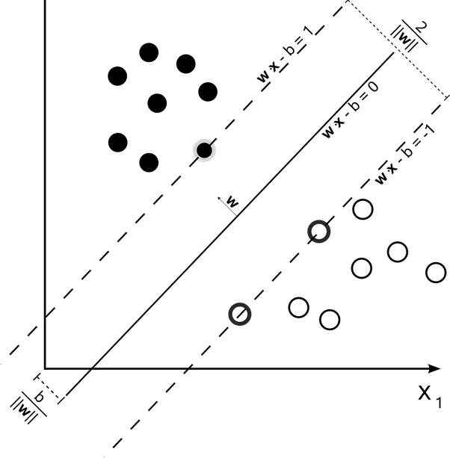

Here we have three support vectors.

The nice thing about acknowledging these support vectors is that we can then formulate the problem of finding the "maximum-margin hyperplane" (the line that best separates the two classes) as an optimization problem that only considers these support vectors. So we can effectively throw out the vast majority of our data, which makes the classification process go much faster than, say, a neural network.

More importantly, by presenting the problem in terms of the support vectors (the so-called *dual form*), we can apply what's called the *kernel trick* to effectively transform the SVM into a non-linear classifier.

Code:

import pandas as pd import numpy as np

import matplotlib.pyplot as plt

from sklearn.metrics import confusion_matrix

#df = pd.read_csv('creditcard.csv', dtype={'v1':int}) df=pd.read_csv('creditcard.csv') count1=df['Class'].astype(bool).sum(axis=0)

count2=df['Class'].count()-df['Class'].astype(bool).sum(axis=0) print(count1)

print(count2) x=df.iloc[:,1:29] y=df['Amount']

from sklearn.preprocessing import StandardScaler obj=StandardScaler()

x1=obj.fit_transform(x) plt.matshow(df.corr())

df_train_all = df[0:150000]

df_train_1 = df_train_all[df_train_all['Class'] == 1] df_train_0 = df_train_all[df_train_all['Class'] == 0] df_sample=df_train_0.sample(300)

df_train = df_train_1.append(df_sample) df_train = df_train.sample(frac=1) x=df.iloc[:,0:30]

y=df['Class']

from sklearn.model_selection import train_test_split

Xtrain, Xtest, ytrain, ytest=train_test_split(x,y,test_size=0.2,random_state=4 2)

from sklearn.svm import LinearSVC obj1=LinearSVC() obj1.fit(Xtrain,ytrain) print(obj1.score(Xtest,ytest)) ypred=obj1.predict(Xtest) confusion_matrix(ytest, ypred)

confusion_matrix(ytrain, obj1.predict(Xtrain))

Dataset

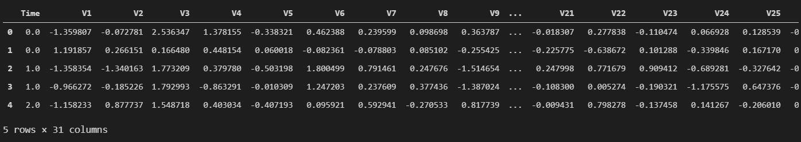

Correlation Matrix

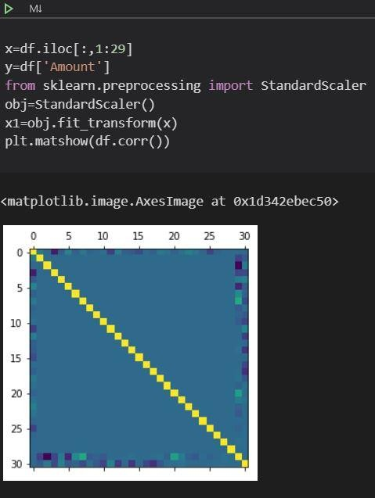

Training

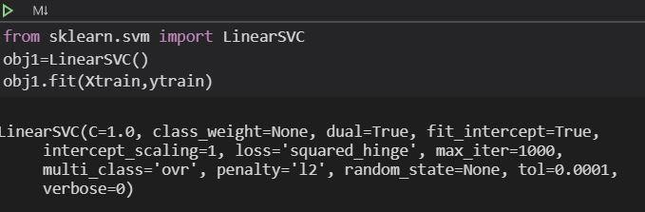

Result

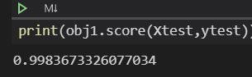

Confusion Matrix

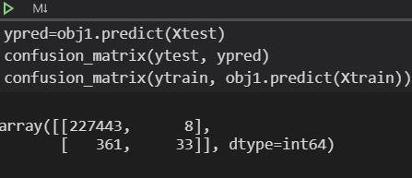

Conclusion:

Thus we have successfully completed the implementation of Support Vector Machine

Assignment 9 – K means

Aim: Implement K means algorithm for multidimensional data for Cars or Wine dataset from UCI repository

Objectives:

1. To learn unsupervised learning
2. To implement K means algorithm

Theory:

Unsupervised learning is a type of machine learning algorithm used to draw inferences from datasets consisting of input data without labelled responses. The most common unsupervised learning method is cluster analysis, which is used for exploratory data analysis to find hidden patterns or grouping in data.

Common clustering algorithms include:

* Hierarchical clustering: builds a multilevel hierarchy of clusters by creating a cluster tree
* k-Means clustering: partitions data into k distinct clusters based on distance to the centroid of a cluster
* Gaussian mixture models: models clusters as a mixture of multivariate normal density components
* Self-organizing maps: uses [neural networks](https://www.mathworks.com/discovery/neural-network.html) that learn the topology and distribution of the data
* Hidden Markov models: uses observed data to recover the sequence of states

Unsupervised learning methods are used in bioinformatics for sequence analysis and genetic clustering; in data mining for sequence and [pattern mining](https://www.mathworks.com/discovery/pattern-recognition.html); in medical imaging for image segmentation; and in computer vision for object recognition.

Clustering and its types:

Clustering is the task of dividing the population or data points into a number of groups such that data points in the same groups are more similar to other data points in the same group than those in other groups. In simple words, the aim is to segregate groups with similar traits and assign them into clusters.

Let’s understand this with an example. Suppose, you are the head of a rental store and wish to understand preferences of your costumers to scale up your business. Is it possible for you to look at details of each costumer and devise a unique business strategy for each one of them? Definitely not. But, what you can do is to cluster all of your costumers into say 10 groups based on their purchasing habits and use a separate strategy for costumers in each of these 10 groups. And this is what we call clustering.

A "clustering" is essentially a set of such clusters, usually containing all objects in the data set. Additionally, it may specify the relationship of the clusters to each other, for example, a hierarchy of clusters embedded in each other. Clustering’s can be roughly distinguished as:

* + Hard clustering: each object belongs to a cluster or not
  + Soft clustering (also: [fuzzy clustering](https://en.wikipedia.org/wiki/Fuzzy_clustering)): each object belongs to each cluster to a certain degree (for example, a likelihood of belonging to the cluster)

Types:

* + Strict partitioning clustering: each object belongs to exactly one cluster
  + Strict partitioning clustering with outliers: objects can also belong to no cluster, and are considered [outliers](https://en.wikipedia.org/wiki/Anomaly_detection)
  + Overlapping clustering (also: alternative clustering, multi-view clustering): objects may belong to more than one cluster; usually involving hard clusters
  + Hierarchical clustering: objects that belong to a child cluster also belong to the parent cluster
  + [Subspace clustering](https://en.wikipedia.org/wiki/Subspace_clustering): while an overlapping clustering, within a uniquely defined subspace, clusters are not expected to overlap

K means algorithm

Kmeans algorithm is an iterative algorithm that tries to partition the dataset into K pre-defined distinct non-overlapping subgroups (clusters) where each data point belongs to only one group. It tries to make the inter-cluster data points as similar as possible while also keeping the clusters as different (far) as possible. It assigns data points to a cluster such that the sum of the squared distance between the data points and the cluster’s centroid (arithmetic mean of all the

data points that belong to that cluster) is at the minimum. The less variation we have within clusters, the more homogeneous (similar) the data points are within the same cluster.

The way k means algorithm works is as follows:

1. Specify number of clusters K.
2. Initialize centroids by first shuffling the dataset and then randomly selecting K data points for the centroids without replacement.
3. Keep iterating until there is no change to the centroids. i.e assignment of data

points to clusters isn’t changing.

* Compute the sum of the squared distance between data points and all centroids.
* Assign each data point to the closest cluster (centroid).
* Compute the centroids for the clusters by taking the average of the all data points that belong to each cluster.

The approach kmeans follows to solve the problem is called Expectation- Maximization.

Code:

import pandas as pd

from matplotlib import pyplot as plt df=pd.read_csv('wine1.csv')

from sklearn.preprocessing import StandardScaler from sklearn.model_selection import train_test_split from sklearn.cluster import KMeans

from sklearn.metrics import accuracy_score km=KMeans(n_clusters=3, max_iter=400,verbose=True,tol=0.2) pred = km.fit_predict(df[['B','C']])

plt.scatter(df['B'], df['C'],c=df['A']) score = accuracy_score(df['A'], pred) score

plt.scatter(df['B'], df['C'], c=pred)

plt.scatter(km.cluster_centers_[:,0] ,km.cluster_centers_[:,1], color='black')

Dataset

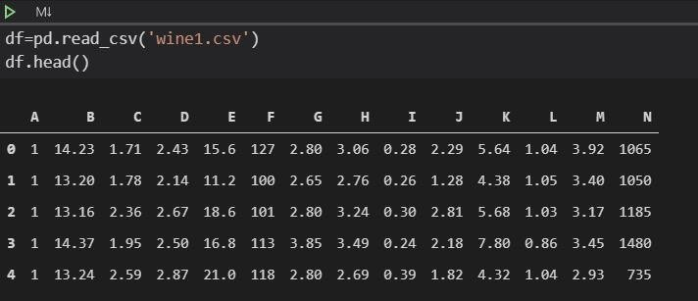

Points before Fitting

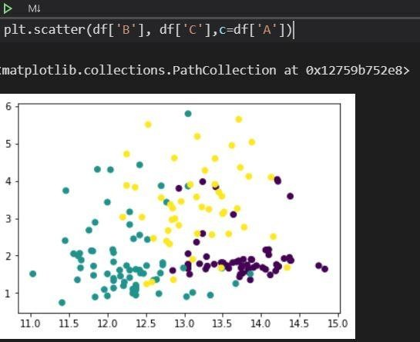

Training

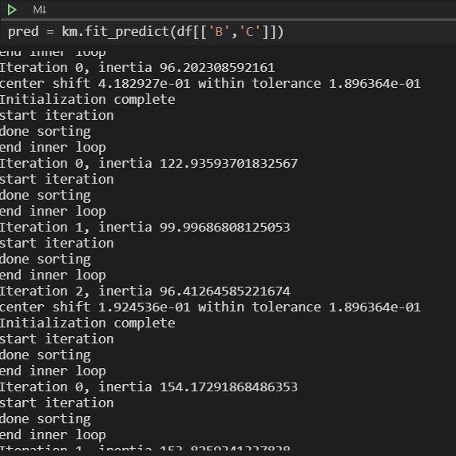

Points after implementing algorithm

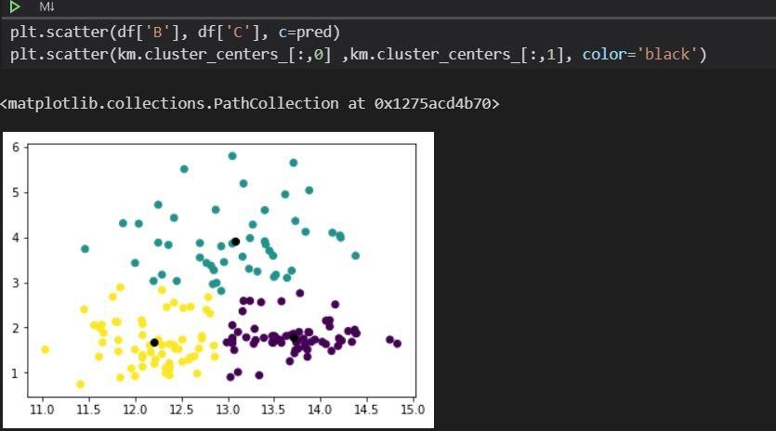

Conclusion

Thus we have successfully completed the implementation of Kmeans algorithm

Assignment 10 - KNN

Aim: Download the famous dataset of iris and Implement KNN algorithm to predict the class to which these plants belong, Calculate the performance matric and compare the error rate with K value( K value range).

# Objectives:

* 1. To learn KNN algorithm
  2. To implement KNN classifier

Theory:

# Lazy learners

Lazy learners simply store the training data and wait until a testing data appear. When it does, classification is conducted based on the most related data in the stored training data. Compared to eager learners, lazy learners have less training time but more time in predicting.

# Eager learners

Eager learners construct a classification model based on the given training data before receiving data for classification. It must be able to commit to a single hypothesis that covers the entire instance space. Due to the model construction, eager learners take a long time for train and less time to predict.

# Lazy learner:

* 1. Just store Data set **without** learning from it
  2. Start classifying data when it receives **Test data**
  3. So, it takes less time learning and more time classifying data

# Eager learner:

1. When it receives data set it starts classifying (learning)
2. Then it does not wait for test data to learn
3. So, it takes long time learning and less time classifying data

KNN Algorithm

The KNN algorithm assumes that similar things exist in close proximity. In other words, similar things are near to each other.

The KNN algorithm hinges on this assumption being true enough for the algorithm to be useful. KNN captures the idea of similarity (sometimes called distance, proximity, or closeness) with some mathematics we might have learned in our childhood— calculating the distance between points on a graph.

# The KNN Algorithm

1. Load the data
2. Initialize K to your chosen number of neighbours
3. For each example in the data
   1. Calculate the distance between the query example and the current example from the data.
   2. Add the distance and the index of the example to an ordered collection
4. Sort the ordered collection of distances and indices from smallest to largest (in ascending order) by the distances
5. Pick the first K entries from the sorted collection
6. Get the labels of the selected K entries
7. If regression, return the mean of the K labels
8. If classification, return the mode of the K labels

Code:

import pandas as pd df=pd.read_csv('IRIS.csv')

from sklearn.preprocessing import StandardScaler from sklearn.model_selection import train_test_split from sklearn.neighbors import KNeighborsClassifier

from sklearn.preprocessing import LabelEncoder le=LabelEncoder()

df.head() x=df.iloc[:,0:3] y=df['species'] obj=StandardScaler() x=obj.fit_transform(x)

le.fit_transform(['Iris-setosa','Iris-versicolor','Iris-virginica']) xtrain, xtest, ytrain, ytest=train_test_split(x,y,test_size=0.3) knn=KNeighborsClassifier(n_neighbors=5)

knn.fit(xtrain,ytrain) print(knn.score(xtest,ytest)) rom sklearn import metrics ypred=knn.predict(xtest) confusion_matrix(ytest,ypred) k_range=range(1,26)

error1={} errorlist=[]

for k in k_range: knn=KNeighborsClassifier(n_neighbors=k) knn.fit(xtrain,ytrain) ypred=knn.predict(xtest)

error1[k]=1-metrics.accuracy_score(ytest,ypred) errorlist.append(1-metrics.accuracy_score(ytest,ypred))

import matplotlib.pyplot as plt plt.plot(k_range, errorlist)

plt.xlabel("K values") plt.ylabel("Error")

Dataset

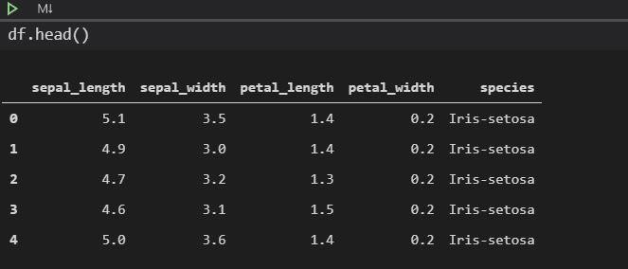

Training

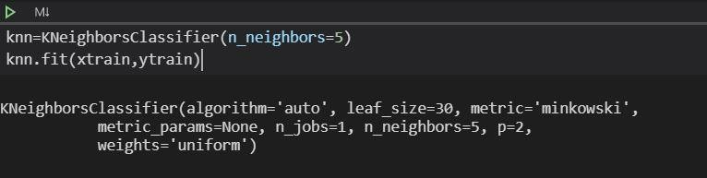

Results

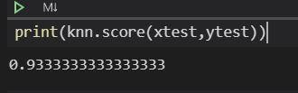

Confusion Matrix

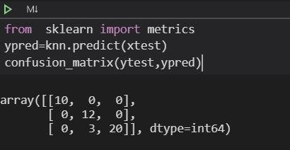

Error Graph

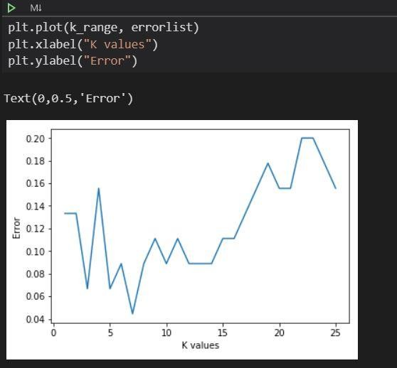

Conclusion

Thus we have successfully completed the implementation of KNN algorithm

Assignment 11 - CNN

Aim: Implement CNN for MNIST/CIFAR10 dataset using tensorflow

# Objectives:

1. To learn basics of deep learning
2. To learn and implement CNN

Theory:

Deep Learning

Deep learning is an [artificial intelligence](https://www.investopedia.com/terms/a/artificial-intelligence-ai.asp) function that imitates the workings of the human brain in processing data and creating patterns for use in decision making. Deep learning is a subset of [machine learning](https://www.investopedia.com/terms/m/machine-learning.asp) in artificial intelligence (AI) that has networks capable of learning unsupervised from data that is unstructured or unlabeled. Also known as deep neural learning or deep neural network.

Deep learning, a subset of machine learning, utilizes a hierarchical level of artificial neural networks to carry out the process of machine learning. The artificial neural networks are built like the human brain, with neuron nodes connected together like a web. While traditional programs build analysis with data in a linear way, the hierarchical function of deep learning systems enables machines to process data with a nonlinear approach.

CNN Architecture

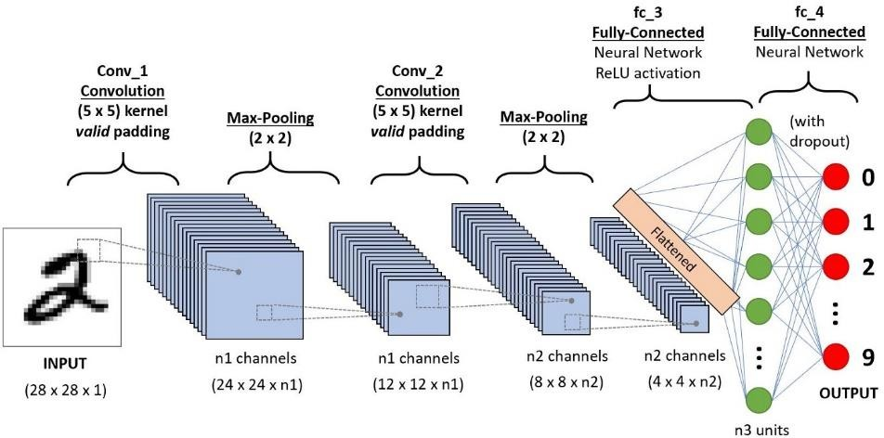

CNN WORKING

A Convolutional Neural Networks Introduction so to speak.

* [Step 1: Convolution Operation](http://www.superdatascience.com/blogs/deep-learning-a-z-convolutional-neural-networks-cnn-step-1-convolution-operation/)

The first building block in our plan of attack is convolution operation. In this step, we will touch on feature detectors, which basically serve as the neural network's filters. We will also discuss feature maps, learning the parameters of such maps, how patterns are detected, the layers of detection, and how the findings are mapped out.

* [Step 1(b): ReLU Layer](http://www.superdatascience.com/blogs/deep-learning-a-z-convolutional-neural-networks-cnn-step-1b-relu-layer/)

The second part of this step will involve the Rectified Linear Unit or ReLU. We will cover ReLU layers and explore how linearity functions in the context of Convolutional Neural Networks.

Not necessary for understanding CNN's, but there's no harm in a quick lesson to improve your skills.

* [Step 2: Pooling](http://www.superdatascience.com/blogs/deep-learning-a-z-convolutional-neural-networks-cnn-step-2-max-pooling/)

In this part, we'll cover pooling and will get to understand exactly how it generally works. Our nexus here, however, will be a specific type of pooling; max pooling. We'll cover various approaches, though, including mean (or sum) pooling. This part will end with a demonstration made using a visual interactive tool that will definitely sort the whole concept out for you.

* [Step 3: Flattening](http://www.superdatascience.com/blogs/deep-learning-a-z-convolutional-neural-networks-cnn-step-3-flattening/)

This will be a brief breakdown of the flattening process and how we move from pooled to flattened layers when working with Convolutional Neural Networks.

* [Step 4: Full Connection](http://www.superdatascience.com/blogs/deep-learning-a-z-convolutional-neural-networks-cnn-step-4-full-connection/)

In this part, everything that we covered throughout the section will be merged together. By learning this, you'll get to envision a fuller picture of how Convolutional Neural Networks operate and how the "neurons" that are finally produced learn the classification of images.

Code

import tensorflow as tp

from tensorflow.keras import datasets,layers, models (train_images,train_labels), (test_images,test_labels)=datasets.cifar10.load_d ata()

train_images, test_images=train_images/255, test_images/255 model = models.Sequential()

model.add(layers.Conv2D(32, (3, 3), activation='relu', input_shape=(32, 32, 3)

))

model.add(layers.MaxPooling2D((2, 2)))

model.add(layers.Conv2D(64, (3, 3), activation='relu'))

model.add(layers.MaxPooling2D((2, 2)))

model.add(layers.Conv2D(64, (3, 3), activation='relu')) model.add(layers.Flatten()) model.add(layers.Dense(64,activation='relu')) model.add(layers.Dense(10))

model.compile(optimizer='SGD',loss=tp.keras.losses.SparseCategoricalCrossentro py(from_logits=True),metrics=['accuracy'])

history=model.fit(train_images, train_labels, epochs=10, validation_data=(test

_images,test_labels)) plt.xlabel('Epoch') plt.ylabel('Accuracy')

test_loss, test_acc = model.evaluate(test_images, test_labels, verbose=2) print(test_acc)

Model making

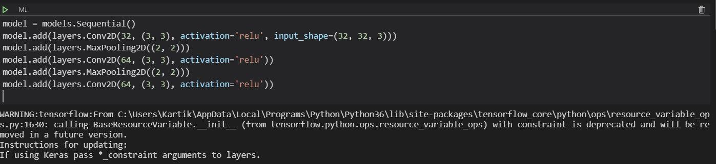

Model Summary

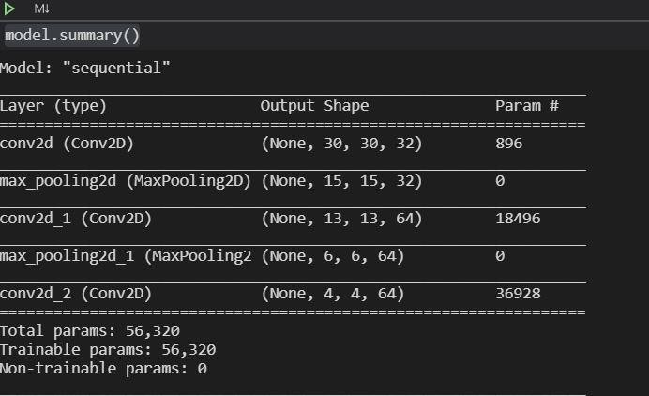

Model Modifications and summary

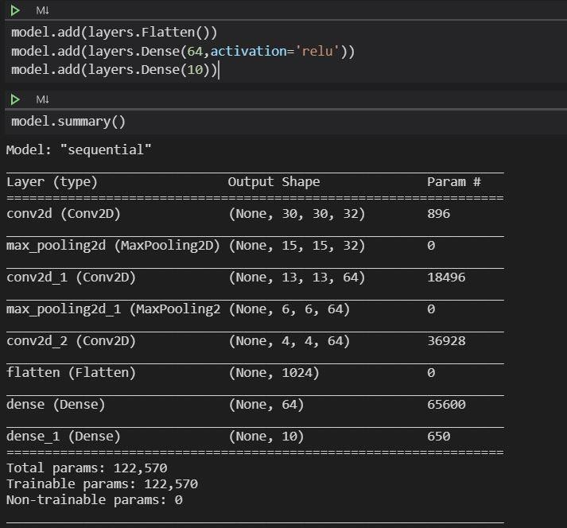

Training

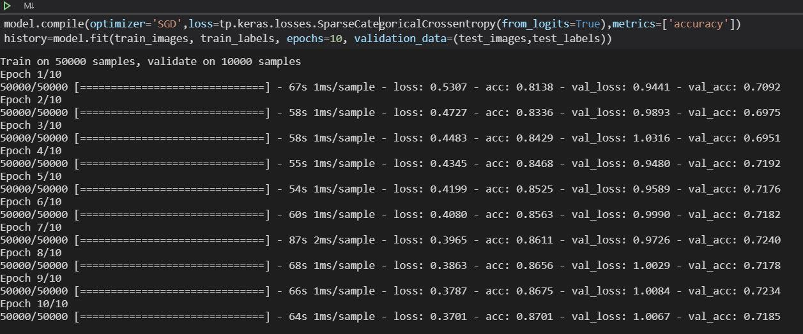

Results

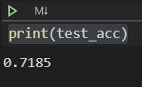

Conclusion

Thus we have successfully completed the implementation of CNN algorithm using tensorflow

Assignment 12 - Images

Aim: Perform basic image processing using opencv

# Objectives:

1. To learn about images processing
2. To perform various operations on images Theory

OpenCV

**OpenCV** (*Open Source Computer Vision Library*) is a [library of programming](https://en.wikipedia.org/wiki/Library_(computing)) [functions](https://en.wikipedia.org/wiki/Library_(computing)) mainly aimed at real-time [computer vision](https://en.wikipedia.org/wiki/Computer_vision).[[1]](https://en.wikipedia.org/wiki/OpenCV#cite_note-1) Originally developed by [Intel](https://en.wikipedia.org/wiki/Intel_Corporation), it was later supported by [Willow Garage](https://en.wikipedia.org/wiki/Willow_Garage) then Itseez (which was later acquired by Intel[[2]](https://en.wikipedia.org/wiki/OpenCV#cite_note-2)). The library is [cross-platform](https://en.wikipedia.org/wiki/Cross-platform) and free for use under the [open-source](https://en.wikipedia.org/wiki/Open-source_software) [BSD license](https://en.wikipedia.org/wiki/BSD_license).

OpenCV supports some models from [deep learning](https://en.wikipedia.org/wiki/Deep_learning) frameworks like [TensorFlow](https://en.wikipedia.org/wiki/TensorFlow), [Torch](https://en.wikipedia.org/wiki/Torch_(machine_learning)), [PyTorch](https://en.wikipedia.org/wiki/PyTorch) (after converting to an ONNX model) and [Caffe](https://en.wikipedia.org/wiki/Caffe_(software)) according to a defined list of supported layers.[[3]](https://en.wikipedia.org/wiki/OpenCV#cite_note-3). It promotes OpenVisionCapsules. [[4]](https://en.wikipedia.org/wiki/OpenCV#cite_note-4), which is a portable format, compatible with all other formats.

Image processing operations

**Digital image processing** is the use of a [digital computer](https://en.wikipedia.org/wiki/Digital_computer) to *process* [digital](https://en.wikipedia.org/wiki/Digital_image) [images](https://en.wikipedia.org/wiki/Digital_image) through an [*algorithm*](https://en.wikipedia.org/wiki/Algorithm).[[1](https://en.wikipedia.org/wiki/Digital_image_processing#cite_note-1)[][2]](https://en.wikipedia.org/wiki/Digital_image_processing#cite_note-Gonzalez_2018_p.-2) As a subcategory or field of [digital signal](https://en.wikipedia.org/wiki/Digital_signal_processing) [processing](https://en.wikipedia.org/wiki/Digital_signal_processing), digital image processing has many advantages over [analog image](https://en.wikipedia.org/wiki/Analog_image_processing) [processing](https://en.wikipedia.org/wiki/Analog_image_processing). It allows a much wider range of algorithms to be applied to the input data and can avoid problems such as the build-up of [noise](https://en.wikipedia.org/wiki/Noise_(signal_processing)) and [distortion](https://en.wikipedia.org/wiki/Distortion) during processing. Since images are defined over two dimensions (perhaps more) digital image processing may be modeled in the form of [multidimensional](https://en.wikipedia.org/wiki/Multidimensional_systems) [systems](https://en.wikipedia.org/wiki/Multidimensional_systems). The generation and development of digital image processing are mainly affected by three factors: first, the development of computers; second, the development of mathematics (especially the creation and improvement of discrete mathematics theory); third, the demand for a wide range of applications in environment, agriculture, military, industry and medical science has increased.

Digital image processing allows the use of much more complex algorithms, and hence, can offer both more sophisticated performance at simple tasks, and the implementation of methods which would be impossible by analogue means.

In particular, digital image processing is a concrete application of, and a practical technology based on:

* [Classification](https://en.wikipedia.org/wiki/Statistical_classification)
* [Feature extraction](https://en.wikipedia.org/wiki/Feature_extraction)
* [Multi-scale signal analysis](https://en.wikipedia.org/wiki/Multi-scale_signal_analysis)
* [Pattern recognition](https://en.wikipedia.org/wiki/Pattern_recognition)
* [Projection](https://en.wikipedia.org/wiki/Graphical_projection)

Some techniques which are used in digital image processing include:

* [Anisotropic diffusion](https://en.wikipedia.org/wiki/Anisotropic_diffusion)
* [Hidden Markov models](https://en.wikipedia.org/wiki/Hidden_Markov_model)
* [Image editing](https://en.wikipedia.org/wiki/Image_editing)
* [Image restoration](https://en.wikipedia.org/wiki/Image_restoration)
* [Independent component analysis](https://en.wikipedia.org/wiki/Independent_component_analysis)
* [Linear filtering](https://en.wikipedia.org/wiki/Linear_filter)
* [Neural networks](https://en.wikipedia.org/wiki/Artificial_neural_networks)
* [Partial differential equations](https://en.wikipedia.org/wiki/Partial_differential_equations)
* [Pixelation](https://en.wikipedia.org/wiki/Pixelation)
* [Point feature matching](https://en.wikipedia.org/wiki/Point_feature_matching)
* [Principal components analysis](https://en.wikipedia.org/wiki/Principal_components_analysis)
* [Self-organizing maps](https://en.wikipedia.org/wiki/Self-organizing_map)
* [Wavelets](https://en.wikipedia.org/wiki/Wavelet) OpenCV methods

# Image Acquisition

OpenCV gives the flexibility to capture image directly from a pre-recorded video stream, camera input feed, or a directory path.

#Taking input from a directory path img = cv2.imread('C:\Users\USER\Desktop\image.jpg',0)#Capturing input from a video stream

cap **=** cv2**.**VideoCapture(0)

Histogram Equalization :

Representation of intensity distribution vs no. of pixels of an image is termed as the histogram.

Equalization stretches out the intensity range in order to suit contrast levels

appropriately. More resources [here](http://docs.opencv.org/3.1.0/d5/daf/tutorial_py_histogram_equalization.html) and [here](http://www.songho.ca/dsp/histogram/histogram.html).

#Taking input from a directory path img = cv2.imread('wiki.jpg',0)#Applying Histogram Equalization equ = cv2.equalizeHist(img)#Save the image cv2.imwrite('res.png',equ)

Erosion and Dilation

Erosion and Dilation belong to the group of morphological transformations and widely used together for the treatment of noise or detection of intensity bumps. [Here’s](http://docs.opencv.org/3.0-beta/doc/py_tutorials/py_imgproc/py_morphological_ops/py_morphological_ops.html) an extensive resource on the same from the documentation.

#Taking input from a directory path img = cv2.imread('wiki.jpg',0)#Applying Erosion img_erosion **=** cv2.erode(img, kernel, iterations**=**1)#Applying Dilation img_dilation **=** cv2.dilate(img, kernel, iterations**=**1)

Image Denoising

Noise has a very peculiar property that its mean is zero, and this is what helps in its removal by averaging it out.

OpenCV provides four variations of this technique.

1. [**cv2.fastNlMeansDenoising()**](http://docs.opencv.org/trunk/d1/d79/group__photo__denoise.html#ga76abf348c234cecd0faf3c42ef3dc715) — works with a single grayscale images
2. [**cv2.fastNlMeansDenoisingColored()**](http://docs.opencv.org/trunk/d1/d79/group__photo__denoise.html#ga21abc1c8b0e15f78cd3eff672cb6c476) — works with a color image.
3. [**cv2.fastNlMeansDenoisingMulti()**](http://docs.opencv.org/trunk/d1/d79/group__photo__denoise.html#gaf4421bf068c4d632ea7f0aa38e0bf172) — works with image sequence captured in short period of time (grayscale images)
4. [**cv2.fastNlMeansDenoisingColoredMulti()**](http://docs.opencv.org/trunk/d1/d79/group__photo__denoise.html#gaa501e71f52fb2dc17ff8ca5e7d2d3619) — same as above, but for color images.

Code

import cv2

import numpy as np image=cv.imread("Lamborghini_Centenario_2017_widescreen_01.jpg") cv.imshow("Image",image)

cv.waitKey(0) image.shape corner=image[0:100,0:100]

cv.imshow("Corner", corner) cv.waitKey(0)

canvas = np.zeros((300, 300, 3), dtype = "uint8") #RGB(255,255,255)

green = (0, 255, 0)

cv.line(canvas, (0, 0), (300, 300), green) cv.imshow("Canvas", canvas)

cv.waitKey(0) red = (0, 0, 255)

cv.line(canvas, (300, 0), (0, 300), red, 3) cv.imshow("Canvas", canvas)

cv.waitKey(0)

M = np.float32([[1, 0, 25], [0, 1, 50]])

shifted = cv.warpAffine(image, M, (image.shape[1], image.shape[0])) cv.imshow("Shifted Down and Right", shifted)

cv.waitKey(0) cv.imshow("Original", image) (h, w) = image.shape[:2] center = (w // 2, h // 2)

M = cv.getRotationMatrix2D(center, -45, 1.0) rotated = cv.warpAffine(image, M, (w, h)) cv.imshow("Rotated by 45 Degrees", rotated) cv.waitKey(0)

cv.imshow("Original", image) print(image.shape)

r = 150.0 / image.shape[1]

dim = (150, int(image.shape[0] * r))

resized = cv.resize(image, dim, interpolation = cv.INTER_AREA) print(resized.shape)

cv.imshow("Resized (Width)", resized) cv.waitKey(0)

cv.imshow("Original", image) flipped = cv.flip(image, 0)

cv.imshow("Flipped Horizontally", flipped) cv.waitKey(0)

Results Cropping:

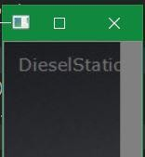

Greenline

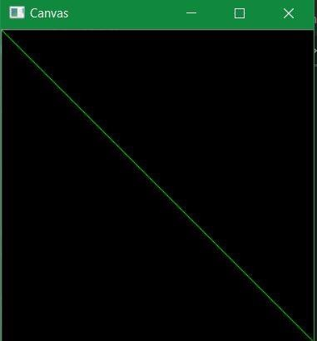

Red Line

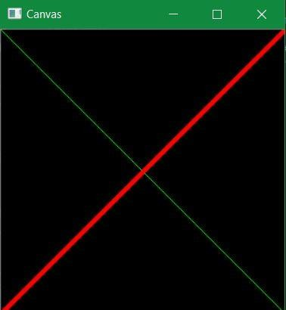

Shifting the image down right



Rotating the image by 45degrees



Resizing the image

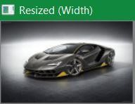

Flipping the image



Conclusion

Thus we have successfully learned the usage of OpenCV and it’s functions